SOFTWARE TESTING – TEST REPORT
Practical 12: AI-Powered Software Testing of The Internet Login Page
1. Test Report Information
Project Name | AI-Powered Software Testing
Practical | Practical 12 – Tutorial 12
Application Under Test | The Internet – Login (https://the-internet.herokuapp.com/login)
Module Tested | Login and Authentication
Test Type | Automated functional, validation, session and regression testing (black box)
Automation Script | P12.py
Executed By | PRAJEET PRAJAPAT
Execution Date | 27-10-2026 (started 10:24:11)
Overall Result | PASS (13 of 13 executions passed)
2. Aim
To analyze AI-powered software testing tools and apply Generative AI techniques for test case generation, test data creation, defect prediction, requirement analysis and automated Selenium test script generation for software quality assurance.
3. Application Under Test
"The Internet" is a public demo web application. Its login page has a username field, a password field and a Login button. A successful login opens a Secure Area page with a Logout button, and the page shows flash messages for success, failure and logout. The credentials published on the page were used for testing.
Requirement tested: A registered user should be able to log in using a valid username and password. Invalid credentials should be rejected and an appropriate error message should be displayed.
4. Test Environment
Parameter | Details
Programming Language | Python 3.14.3
Automation Tool | Selenium WebDriver 4.49.0
Browser | Google Chrome 154.0.8037.58
IDE | PyCharm
AI Tool | Generative AI (used as an assistant; output reviewed by the tester)
Target URL | https://the-internet.herokuapp.com/login
Test Data | Valid: tomsmith / SuperSecretPassword!  Invalid password: wrong123  Invalid username: wrong_user  Blank fields for empty-input tests
5. AI-Assisted Testing Activities
Generative AI was used as an assistant for the following activities. The tester reviewed each output before it was used, and the executed script verified the results.
Sr. No. | Activity | Outcome | Test IDs
1 | Requirement analysis | 6 testable scenarios identified: valid login, negative login, error message validation, form validation, logout and regression | All
2 | Test case generation | 5 negative/validation cases, a valid login case, logout, form-element and secure-page cases: 9 test cases in total | TC-12-01 to 09
3 | Test data creation | Valid credentials, wrong password, wrong username and blank inputs | TC-12-01 to 06
4 | Defect prediction | 5 defect-prone areas predicted (input validation, authentication, error handling, session management, user interaction); each mapped to tests | TC-12-02 to 09
5 | Selenium script generation | Python Selenium script produced and reviewed (locators, syntax, assertions, error handling) | P12.py
6 | Regression scenarios | 4 key login scenarios re-executed | RT-01 to RT-04
7 | Human review | Test data adapted to the application; empty-input expected results aligned with the actual error messages | –
6. Testing Scenarios
Area | Scenarios | Test IDs
Valid login / successful authentication | Valid username and password | TC-12-01
Invalid credentials | Invalid password, invalid username | TC-12-02, 03
Empty / invalid input | Empty username, empty password, both empty | TC-12-04, 05, 06
Error message validation | Message text checked in every negative test | TC-12-02 to 06
Logout | Logout after successful login | TC-12-07
Form validation | Form fields present, password masked | TC-12-08
Session management | Secure page opened directly without login | TC-12-09
Regression | Valid login, invalid password, invalid username, empty username | RT-01 to RT-04
7. Test Case Execution
Results below are taken from the actual console output of P12.py.
Test ID | Scenario | Test Data | Expected Result | Actual Result | Status
TC-12-01 | Valid Login | tomsmith / SuperSecretPassword! | Login succeeds; Secure Area page opens with success message | URL = https://the-internet.herokuapp.com/secure, heading = 'Secure Area', message = 'You logged into a secure area!' | PASS
TC-12-02 | Invalid Password | tomsmith / wrong123 | Error "Your password is invalid!" shown; no access | Error shown: 'Your password is invalid!' | PASS
TC-12-03 | Invalid Username | wrong_user / SuperSecretPassword! | Error "Your username is invalid!" shown; no access | Error shown: 'Your username is invalid!' | PASS
TC-12-04 | Empty Username | Blank / SuperSecretPassword! | Error "Your username is invalid!" shown; no access | Error shown: 'Your username is invalid!' | PASS
TC-12-05 | Empty Password | tomsmith / Blank | Error "Your password is invalid!" shown; no access | Error shown: 'Your password is invalid!' | PASS
TC-12-06 | Empty Username and Password | Blank / Blank | Error "Your username is invalid!" shown; no access | Error shown: 'Your username is invalid!' | PASS
TC-12-07 | Logout | tomsmith / SuperSecretPassword! | Returns to login page with logout message | URL = https://the-internet.herokuapp.com/login, message = 'You logged out of the secure area!' | PASS
TC-12-08 | Login Form Elements | – | Both fields and Login button shown; password masked | Heading = 'Login Page', fields and Login button displayed, password field type = 'password' | PASS
TC-12-09 | Secure Page Access Without Login | Direct URL /secure | Redirected to login page with message | Redirected to https://the-internet.herokuapp.com/login, message = 'You must login to view the secure area!' | PASS
8. Regression Test Execution
Test ID | Scenario | Expected Result | Actual Result | Status
RT-01 | Valid Login | Login successful | URL = https://the-internet.herokuapp.com/secure, heading = 'Secure Area', message = 'You logged into a secure area!' | PASS
RT-02 | Invalid Password | Error displayed | Error shown: 'Your password is invalid!' | PASS
RT-03 | Invalid Username | Error displayed | Error shown: 'Your username is invalid!' | PASS
RT-04 | Empty Username | Error displayed | Error shown: 'Your username is invalid!' | PASS
9. Execution Summary
Metric | Value
Automation Scripts Executed | 1
Test Cases Executed | 9
Regression Tests Executed | 4 (4 passed)
Total Executed | 13
Passed | 13
Failed | 0
Pass Percentage | 100%
Execution Time | 80.01 seconds
Overall Status | PASS
10. Observations
Sr. No. | Observation
1 | All 13 executions passed and no defects were found in the tested scenarios.
2 | None of the invalid or empty inputs allowed access to the Secure Area.
3 | For an empty username, and for both fields empty, the application shows "Your username is invalid!". For an empty password it shows "Your password is invalid!". There is no separate "field required" message, so the expected results were set to these messages after human review.
4 | Opening /secure directly without logging in redirected to the login page with a message, and logout ended the session correctly.
5 | The password field is masked (type = password).
6 | All five AI-predicted defect-prone areas were tested and none showed a defect. The AI-suggested expected result for empty input needed adjustment, which shows why AI output must be reviewed.
7 | Testing used one user account and one browser, so results apply to those conditions only.
11. Evidence
Insert the screenshots below before submission.
Figure 1: AI prompt and AI-generated test cases
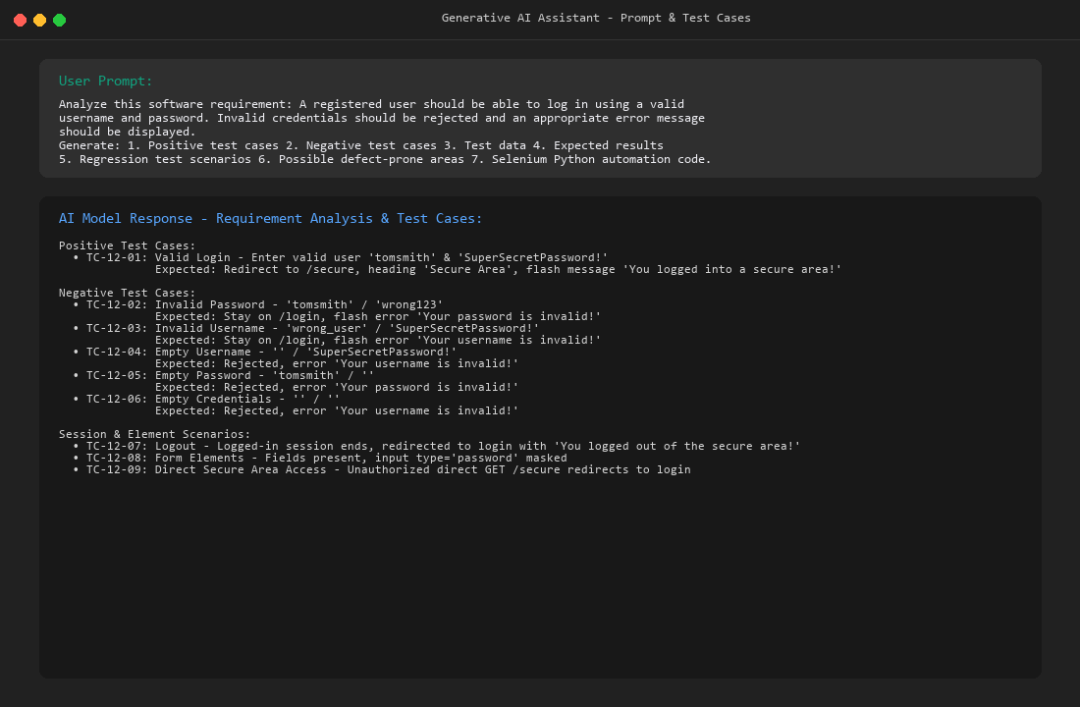
Figure 2: AI-generated test data and defect-prone areas
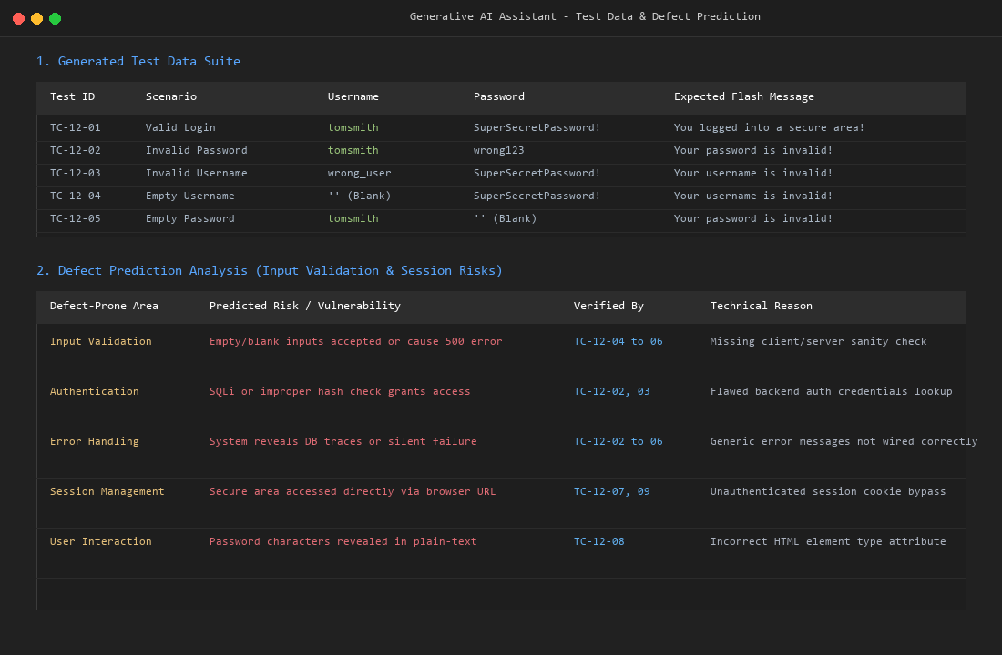
Figure 3: Reviewed Selenium code in PyCharm
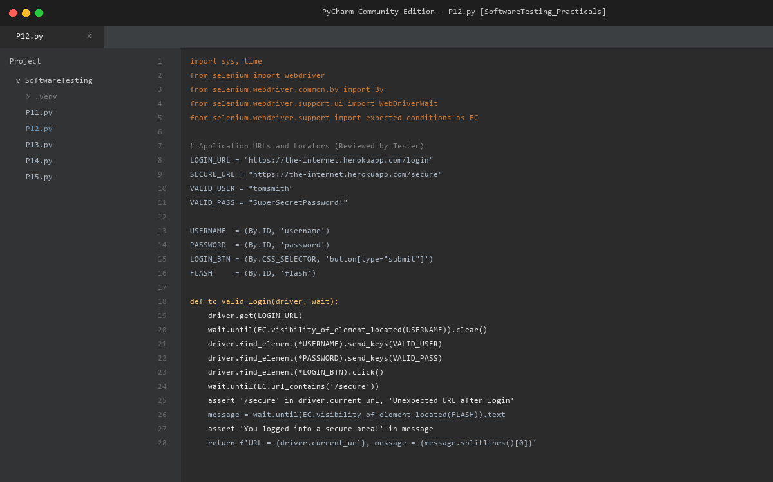
Figure 4: Login page (browser execution)
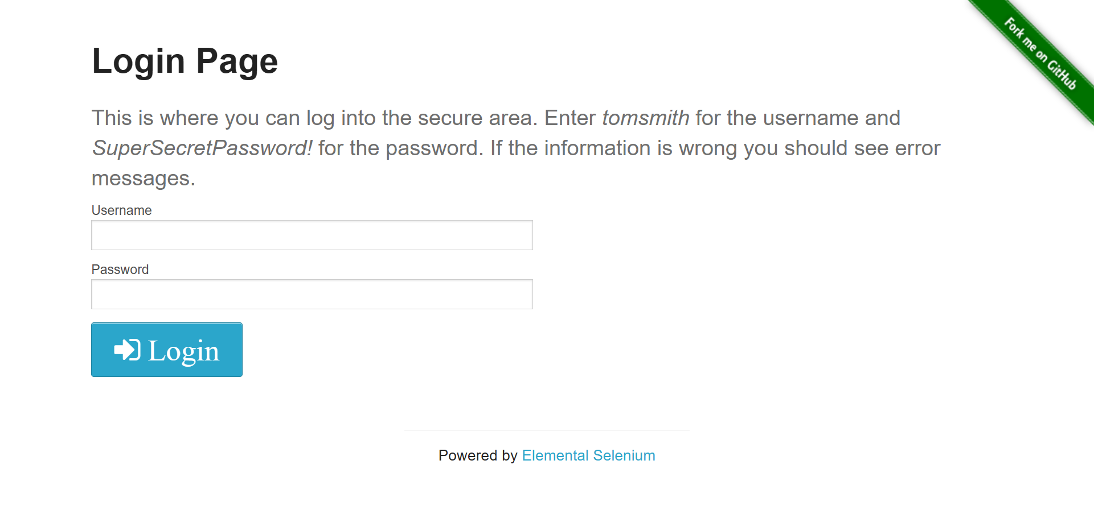
Figure 5: Secure Area page after valid login
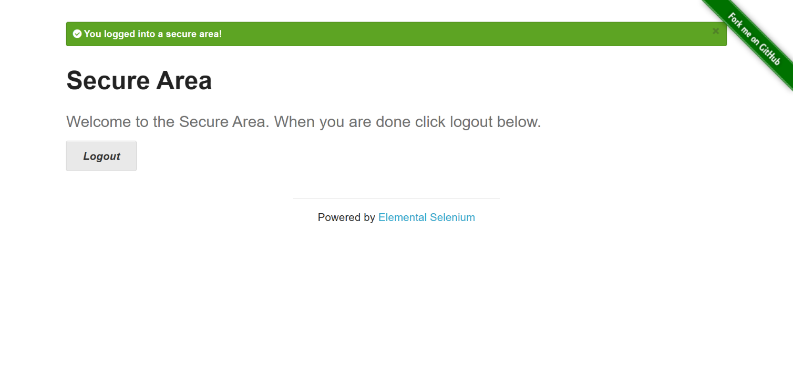
Figure 6: Error message for invalid login
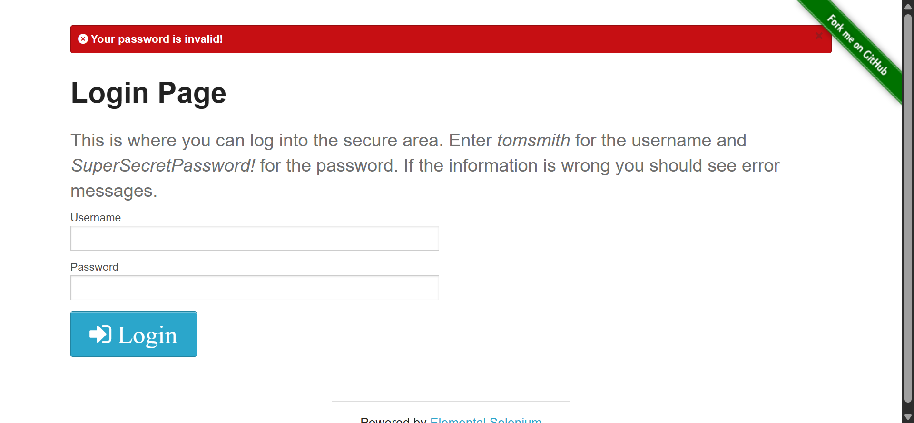
Appendix A: Console Output
======================================================================
Practical 12 - AI-Powered Software Testing (The Internet - Login)
Execution started: 02-10-2026 10:24:11
======================================================================

REQUIREMENT:
A registered user should be able to log in using a valid username and password.
Invalid credentials should be rejected and an appropriate error message displayed.

AI-ASSISTED REQUIREMENT ANALYSIS (reviewed by tester):
Valid user can log in -> Valid Login [TC-12-01]
Invalid credentials rejected -> Negative Login (invalid password / username) [TC-12-02, TC-12-03]
Error should be displayed -> Error Message Validation [TC-12-02 to TC-12-06]
Login must use username/password -> Form Validation (empty fields, form elements) [TC-12-04 to TC-12-06, TC-12-08]
User can end the session -> Logout [TC-12-07]
Existing login must continue working -> Regression Testing [RT-01 to RT-04]

AI-PREDICTED DEFECT-PRONE AREAS (reviewed by tester):
Input validation Empty or invalid input may be accepted or handled wrongly [TC-12-04, 05, 06]
Authentication Wrong username/password may be accepted by mistake [TC-12-02, 03]
Error handling Missing or incorrect error messages [TC-12-02 to 06]
Session management Secure page reachable without login; session not ended on logout [TC-12-07, 09]
User interaction Missing form fields or unmasked password field [TC-12-08]

TEST DATA:
Valid credentials : tomsmith / SuperSecretPassword!
TC-12-02 Invalid Password user='tomsmith' password='wrong123'
TC-12-03 Invalid Username user='wrong_user' password='SuperSecretPassword!'
TC-12-04 Empty Username user='' password='SuperSecretPassword!'
TC-12-05 Empty Password user='tomsmith' password=''
TC-12-06 Empty Username and Password user='' password=''

ENVIRONMENT:
Browser : chrome 154.0.8037.58
Selenium: 4.49.0
Python : 3.14.3
URL : https://the-internet.herokuapp.com/login

======================================================================
TEST EXECUTION
======================================================================

--- TC-12-01: Valid Login ---
Result : PASS
Detail : URL = https://the-internet.herokuapp.com/secure, heading = 'Secure Area', message = 'You logged into a secure area!'

--- TC-12-02: Invalid Password ---
Result : PASS
Detail : Error shown: 'Your password is invalid!'

--- TC-12-03: Invalid Username ---
Result : PASS
Detail : Error shown: 'Your username is invalid!'

--- TC-12-04: Empty Username ---
Result : PASS
Detail : Error shown: 'Your username is invalid!'

--- TC-12-05: Empty Password ---
Result : PASS
Detail : Error shown: 'Your password is invalid!'

--- TC-12-06: Empty Username and Password ---
Result : PASS
Detail : Error shown: 'Your username is invalid!'

--- TC-12-07: Logout ---
Result : PASS
Detail : URL = https://the-internet.herokuapp.com/login, message = 'You logged out of the secure area!'

--- TC-12-08: Login Form Elements ---
Result : PASS
Detail : Heading = 'Login Page', username/password fields and Login button displayed, password field type = 'password'

--- TC-12-09: Secure Page Access Without Login ---
Result : PASS
Detail : Redirected to https://the-internet.herokuapp.com/login, message = 'You must login to view the secure area!'

======================================================================
REGRESSION RE-EXECUTION
======================================================================

--- RT-01: Regression: Valid Login ---
Result : PASS
Detail : URL = https://the-internet.herokuapp.com/secure, heading = 'Secure Area', message = 'You logged into a secure area!'

--- RT-02: Regression: Invalid Password ---
Result : PASS
Detail : Error shown: 'Your password is invalid!'

--- RT-03: Regression: Invalid Username ---
Result : PASS
Detail : Error shown: 'Your username is invalid!'

--- RT-04: Regression: Empty Username ---
Result : PASS
Detail : Error shown: 'Your username is invalid!'

======================================================================
EXECUTION SUMMARY
======================================================================
TC-12-01 Valid Login PASS
TC-12-02 Invalid Password PASS
TC-12-03 Invalid Username PASS
TC-12-04 Empty Username PASS
TC-12-05 Empty Password PASS
TC-12-06 Empty Username and Password PASS
TC-12-07 Logout PASS
TC-12-08 Login Form Elements PASS
TC-12-09 Secure Page Access Without Login PASS
RT-01 Regression: Valid Login PASS
RT-02 Regression: Invalid Password PASS
RT-03 Regression: Invalid Username PASS
RT-04 Regression: Empty Username PASS
----------------------------------------------------------------------
Automation scripts executed : 1 (PR12.py)
Test cases executed : 9
Regression tests executed : 4 (passed: 4)
Total executed : 13
Passed : 13
Failed : 0
Execution time : 80.01 seconds
Overall status : PASS
======================================================================
Appendix B: Source Code (P12.py)
"""
Practical 12 - AI-Powered Software Testing (Software Testing)
Application Under Test : The Internet - Login page
https://the-internet.herokuapp.com/login
Tool / Language : Selenium WebDriver + Python (Google Chrome, PyCharm)

Requirement (used for AI-assisted analysis):
"A registered user should be able to log in using a valid username and
password. Invalid credentials should be rejected and an appropriate
error message should be displayed."

The test design (scenarios, test data, defect-prone areas) is prepared with a
Generative AI assistant and then REVIEWED and corrected by the tester before
execution. This script contains the reviewed test data and the reviewed
Selenium code. Results are produced only when the script is executed.

Test credentials published on the login page itself:
Username: tomsmith Password: SuperSecretPassword!

Install : pip install selenium
Run : python PR12.py
"""

import sys
import time
from datetime import datetime

import selenium
from selenium import webdriver
from selenium.common.exceptions import (
NoSuchElementException,
TimeoutException,
WebDriverException,
)
from selenium.webdriver.common.by import By
from selenium.webdriver.support import expected_conditions as EC
from selenium.webdriver.support.ui import WebDriverWait

# --------------------------------------------------------------------------
# Application data
# --------------------------------------------------------------------------
LOGIN_URL = "https://the-internet.herokuapp.com/login"
SECURE_URL = "https://the-internet.herokuapp.com/secure"

VALID_USER = "tomsmith"
VALID_PASS = "SuperSecretPassword!"

MSG_USERNAME_INVALID = "Your username is invalid!"
MSG_PASSWORD_INVALID = "Your password is invalid!"
MSG_LOGIN_SUCCESS = "You logged into a secure area!"
MSG_LOGOUT_SUCCESS = "You logged out of the secure area!"
MSG_LOGIN_REQUIRED = "You must login to view the secure area!"

# --------------------------------------------------------------------------
# Locators
# --------------------------------------------------------------------------
USERNAME = (By.ID, "username")
PASSWORD = (By.ID, "password")
LOGIN_BTN = (By.CSS_SELECTOR, "button[type='submit']")
FLASH = (By.ID, "flash")
HEADING = (By.TAG_NAME, "h2")
LOGOUT_BTN = (By.CSS_SELECTOR, "a[href='/logout']")

# --------------------------------------------------------------------------
# AI-assisted test design (reviewed by tester)
# --------------------------------------------------------------------------
REQUIREMENT_ANALYSIS = [
("Valid user can log in", "Valid Login", "TC-12-01"),
("Invalid credentials rejected", "Negative Login (invalid password / username)", "TC-12-02, TC-12-03"),
("Error should be displayed", "Error Message Validation", "TC-12-02 to TC-12-06"),
("Login must use username/password", "Form Validation (empty fields, form elements)", "TC-12-04 to TC-12-06, TC-12-08"),
("User can end the session", "Logout", "TC-12-07"),
("Existing login must continue working", "Regression Testing", "RT-01 to RT-04"),
]

DEFECT_PRONE_AREAS = [
("Input validation", "Empty or invalid input may be accepted or handled wrongly", "TC-12-04, 05, 06"),
("Authentication", "Wrong username/password may be accepted by mistake", "TC-12-02, 03"),
("Error handling", "Missing or incorrect error messages", "TC-12-02 to 06"),
("Session management", "Secure page reachable without login; session not ended on logout", "TC-12-07, 09"),
("User interaction", "Missing form fields or unmasked password field", "TC-12-08"),
]

# (test id, scenario, username, password, expected flash message)
NEGATIVE_DATA = [
("TC-12-02", "Invalid Password", VALID_USER, "wrong123", MSG_PASSWORD_INVALID),
("TC-12-03", "Invalid Username", "wrong_user", VALID_PASS, MSG_USERNAME_INVALID),
("TC-12-04", "Empty Username", "", VALID_PASS, MSG_USERNAME_INVALID),
("TC-12-05", "Empty Password", VALID_USER, "", MSG_PASSWORD_INVALID),
("TC-12-06", "Empty Username and Password", "", "", MSG_USERNAME_INVALID),
]

# --------------------------------------------------------------------------
# Result tracking
# --------------------------------------------------------------------------
results = [] # (test_id, scenario, status, detail)

def run_test(test_id, scenario, func):
"""Execute one test, handle exceptions, print and record the outcome."""
print(f"\n--- {test_id}: {scenario} ---")
try:
detail = func()
status = "PASS"
except AssertionError as err:
status, detail = "FAIL", f"Assertion failed: {err}"
except TimeoutException:
status, detail = "FAIL", "TimeoutException: expected element/condition not found in time"
except NoSuchElementException as err:
status, detail = "FAIL", f"NoSuchElementException: {err.msg}"
except WebDriverException as err:
status, detail = "FAIL", f"WebDriverException: {str(err).splitlines()[0]}"

results.append((test_id, scenario, status, detail))
print(f"Result : {status}")
print(f"Detail : {detail}")
return status == "PASS"

# --------------------------------------------------------------------------
# Reusable page actions
# --------------------------------------------------------------------------
def open_login_page(driver, wait):
"""Open the login page with a clean session (no cookies from earlier tests)."""
driver.get(LOGIN_URL)
driver.delete_all_cookies()
driver.get(LOGIN_URL)
wait.until(EC.visibility_of_element_located(USERNAME))

def submit_login(driver, wait, username, password):
user_field = wait.until(EC.visibility_of_element_located(USERNAME))
pass_field = driver.find_element(*PASSWORD)
user_field.clear()
pass_field.clear()
if username:
user_field.send_keys(username)
if password:
pass_field.send_keys(password)
wait.until(EC.element_to_be_clickable(LOGIN_BTN)).click()

def flash_text(wait):
return wait.until(EC.visibility_of_element_located(FLASH)).text

# --------------------------------------------------------------------------
# Test cases
# --------------------------------------------------------------------------
def tc_valid_login(driver, wait):
open_login_page(driver, wait)
submit_login(driver, wait, VALID_USER, VALID_PASS)
wait.until(EC.url_contains("/secure"))
assert "/secure" in driver.current_url, f"Unexpected URL: {driver.current_url}"
message = flash_text(wait)
assert MSG_LOGIN_SUCCESS in message, f"Unexpected message: {message}"
heading = driver.find_element(*HEADING).text
assert "Secure Area" in heading, f"Unexpected heading: {heading}"
assert driver.find_element(*LOGOUT_BTN).is_displayed(), "Logout button not displayed"
return f"URL = {driver.current_url}, heading = '{heading}', message = '{message.splitlines()[0]}'"

def tc_negative_login(driver, wait, username, password, expected_message):
open_login_page(driver, wait)
submit_login(driver, wait, username, password)
message = flash_text(wait)
assert expected_message in message, f"Expected '{expected_message}', found '{message.splitlines()[0]}'"
assert "/secure" not in driver.current_url, "User must not reach the secure area"
assert driver.find_element(*USERNAME).is_displayed(), "Login form should still be displayed"
return f"Error shown: '{message.splitlines()[0]}'"

def tc_logout(driver, wait):
open_login_page(driver, wait)
submit_login(driver, wait, VALID_USER, VALID_PASS)
wait.until(EC.url_contains("/secure"))
wait.until(EC.element_to_be_clickable(LOGOUT_BTN)).click()
wait.until(EC.url_contains("/login"))
message = flash_text(wait)
assert MSG_LOGOUT_SUCCESS in message, f"Unexpected message: {message}"
assert driver.find_element(*USERNAME).is_displayed(), "Login form should be displayed after logout"
return f"URL = {driver.current_url}, message = '{message.splitlines()[0]}'"

def tc_login_form_elements(driver, wait):
open_login_page(driver, wait)
heading = driver.find_element(*HEADING).text
assert "Login Page" in heading, f"Unexpected heading: {heading}"
assert driver.find_element(*USERNAME).is_displayed(), "Username field not displayed"
assert driver.find_element(*PASSWORD).is_displayed(), "Password field not displayed"
assert driver.find_element(*LOGIN_BTN).is_displayed(), "Login button not displayed"
field_type = driver.find_element(*PASSWORD).get_attribute("type")
assert field_type == "password", f"Password field type is '{field_type}'"
return f"Heading = '{heading}', username/password fields and Login button displayed, password field type = '{field_type}'"

def tc_secure_page_without_login(driver, wait):
open_login_page(driver, wait)
driver.get(SECURE_URL)
wait.until(EC.url_contains("/login"))
message = flash_text(wait)
assert MSG_LOGIN_REQUIRED in message, f"Unexpected message: {message}"
assert "/secure" not in driver.current_url, "Secure page must not open without login"
return f"Redirected to {driver.current_url}, message = '{message.splitlines()[0]}'"

# --------------------------------------------------------------------------
# Driver and reporting
# --------------------------------------------------------------------------
def build_driver():
options = webdriver.ChromeOptions()
# Stops Chrome password-manager / breach pop-ups from interfering with the test
options.add_experimental_option("prefs", {
"credentials_enable_service": False,
"profile.password_manager_enabled": False,
"profile.password_manager_leak_detection": False,
})
options.add_experimental_option("excludeSwitches", ["enable-automation"])
driver = webdriver.Chrome(options=options)
driver.maximize_window()
return driver

def print_design_overview():
print("\nREQUIREMENT:")
print(" A registered user should be able to log in using a valid username and password.")
print(" Invalid credentials should be rejected and an appropriate error message displayed.")

print("\nAI-ASSISTED REQUIREMENT ANALYSIS (reviewed by tester):")
for requirement, scenario, ids in REQUIREMENT_ANALYSIS:
print(f" {requirement:<38} -> {scenario} [{ids}]")

print("\nAI-PREDICTED DEFECT-PRONE AREAS (reviewed by tester):")
for area, risk, ids in DEFECT_PRONE_AREAS:
print(f" {area:<20} {risk} [{ids}]")

print("\nTEST DATA:")
print(f" Valid credentials : {VALID_USER} / {VALID_PASS}")
for test_id, scenario, user, pwd, expected in NEGATIVE_DATA:
print(f" {test_id} {scenario:<30} user='{user}' password='{pwd}'")

def print_summary(elapsed):
main_results = [r for r in results if r[0].startswith("TC-")]
regression = [r for r in results if r[0].startswith("RT-")]
total = len(results)
passed = sum(1 for r in results if r[2] == "PASS")
failed = total - passed
reg_passed = sum(1 for r in regression if r[2] == "PASS")

print("\n" + "=" * 70)
print("EXECUTION SUMMARY")
print("=" * 70)
for test_id, scenario, status, _ in results:
print(f"{test_id:<10} {scenario:<45} {status}")
print("-" * 70)
print(f"Automation scripts executed : 1 (PR12.py)")
print(f"Test cases executed : {len(main_results)}")
print(f"Regression tests executed : {len(regression)} (passed: {reg_passed})")
print(f"Total executed : {total}")
print(f"Passed : {passed}")
print(f"Failed : {failed}")
print(f"Execution time : {elapsed:.2f} seconds")
print(f"Overall status : {'PASS' if failed == 0 and total > 0 else 'FAIL'}")
print("=" * 70)

def main():
print("=" * 70)
print("Practical 12 - AI-Powered Software Testing (The Internet - Login)")
print(f"Execution started: {datetime.now():%d-%m-%Y %H:%M:%S}")
print("=" * 70)
print_design_overview()

start = time.time()
driver = None
try:
driver = build_driver()
wait = WebDriverWait(driver, 10)
print("\nENVIRONMENT:")
print(f" Browser : {driver.capabilities.get('browserName')} {driver.capabilities.get('browserVersion')}")
print(f" Selenium: {selenium.__version__}")
print(f" Python : {sys.version.split()[0]}")
print(f" URL : {LOGIN_URL}")

print("\n" + "=" * 70)
print("TEST EXECUTION")
print("=" * 70)

run_test("TC-12-01", "Valid Login", lambda: tc_valid_login(driver, wait))
for test_id, scenario, user, pwd, expected in NEGATIVE_DATA:
run_test(test_id, scenario,
lambda u=user, p=pwd, e=expected: tc_negative_login(driver, wait, u, p, e))
run_test("TC-12-07", "Logout", lambda: tc_logout(driver, wait))
run_test("TC-12-08", "Login Form Elements", lambda: tc_login_form_elements(driver, wait))
run_test("TC-12-09", "Secure Page Access Without Login", lambda: tc_secure_page_without_login(driver, wait))

print("\n" + "=" * 70)
print("REGRESSION RE-EXECUTION")
print("=" * 70)

run_test("RT-01", "Regression: Valid Login", lambda: tc_valid_login(driver, wait))
regression_cases = [
("RT-02", "Regression: Invalid Password", NEGATIVE_DATA[0]),
("RT-03", "Regression: Invalid Username", NEGATIVE_DATA[1]),
("RT-04", "Regression: Empty Username", NEGATIVE_DATA[2]),
]
for rt_id, scenario, data in regression_cases:
_, _, user, pwd, expected = data
run_test(rt_id, scenario,
lambda u=user, p=pwd, e=expected: tc_negative_login(driver, wait, u, p, e))

except WebDriverException as err:
print(f"\nCRITICAL ERROR: could not start or continue the browser session.\n{err}")
finally:
if driver is not None:
driver.quit()
print_summary(time.time() - start)

if __name__ == "__main__":
main()

